**WEEK 3 ASSIGNMENT :** **WAP in HTML to display list of atleast 30 mathematical equations and 30 chemical equations.**

**OBJECTIVES:**

1. Display Mathematical and Chemical Equations in a Well-Formatted Manner using HTML elements like <sup>, <sub> , etc.
2. Structure the content using **ordered lists** (<ol>), <h1> headings, and <hr> horizontal rules to separate sections.

**SOURCE CODE:**

<!DOCTYPE html>

<html>

<head>

<title>30 Mathematical and Chemical equations</title>

</head>

<body>

<hr>

<h1>30 Mathematical equations</h1>

<ol type="1">

<li> (a + b)<sup>2 = </sup>a<sup>2 </sup>+ b<sup>2</sup> + 2ab </li> <br>

<li> (a - b)<sup>2 = </sup>a<sup>2</sup> + b<sup>2</sup> - 2ab </li> <br>

<li> a<sup>2</sup> - b<sup>2</sup> = (a - b)(a + b) </li> <br>

<li> x<sup>3</sup> + y<sup>3</sup> = (x + y)(x<sup>2</sup> - xy + y<sup>2</sup>) </li> <br>

<li> x<sup>3</sup> - y<sup>3</sup> = (x - y)(x<sup>2</sup> + xy + y<sup>2</sup>) </li> <br>

<li> sin<sup>2</sup>x + cos<sup>2</sup>x = 1 </li> <br>

<li> A = &pi;r<sup>2</sup> </li> <br>

<li> C = 2&pi;r </li> <br>

<li> V = 4/3&pi;r<sup>3</sup> </li> <br>

<li> S = n/2(a + l) </li> <br>

<li> a<sub>n</sub> = a<sub>1</sub> + (n -1)d </li> <br>

<li> A = P(1 + r)<sup>t</sup> </li> <br>

<li> P(A∩B) = P(A)P(B) </li> <br>

<li> ∫xndx = x<sup>n+1</sup> / n+1​ + C </li> <br>

<li> lim<sub>x→0</sub>

​<math>

<mfrac>

<mn>sinx</mn>

<mn>x</mn>

</mfrac>

</math>

&nbsp;​= 1

</li> <br>

<li> <math>

<mfrac>

<mn>d</mn><mn>dx</mn>

</mfrac>

</math>​(x<sup>n</sup>)=nx<sup>n−1</sup>

</li> <br>

<li> e<sup>ix</sup> = cosx + isinx </li> <br>

<li> f(x) = ae<sup>bx</sup> + c </li> <br>

<li> log(ab) = loga + logb </li> <br>

<li> log(a<sup>b</sup>) = bloga </li> <br>

<li>

tanx=

​<math>

<mfrac>

<mn>sinx</mn>

<mn>cosx</mn>

</mfrac>

</math>

</li> <br>

<li>

​<math>

x =

<mfrac>

<mn>−b ± <math><msqrt>b2−4ac</msqrt></math></mn>

<mn>2a</mn>

</mfrac>

</math>

</li> <br>

<li> y−y<sub>1</sub> ​= m(x−x<sub>1</sub>) </li> <br>

<li> d =<math><msqrt><mn>(x<sub>2</sub>​−x<sub>1</sub>​)<sup>2</sup>+(y<sub>2</sub>​−y<sub>1</sub>)<sup>2</sup></mn></msqrt></math></li> <br>

<li>

M = (

​<math>

<mfrac>

<mn>x1​+x2</mn>

<mn>2</mn>

</mfrac>,

<mfrac>

<mn>y1​+y2​</mn>

<mn>2</mn>

</mfrac>

</math>

)

</li> <br>

<li>

<math>

<mfrac>

<mn>d</mn><mn>dx</mn>

</mfrac>

</math>​(e<sup>x</sup>) = e<sup>x</sup>

</li> <br>

<li>

A = ​

<math>

<mfrac>

<mn>1</mn><mn>2</mn>

</mfrac>

</math>

bh

</li> <br>

<li>

S =

<math>

<mfrac>

<mn>A</mn><mn>1 - r</mn>

</mfrac>

</math>

</li> <br>

<li>

c<sup>2</sup> = a<sup>2</sup> + b<sup>2</sup> − 2abcosC

</li> <br>

<li>

<math>

<mfrac>

<mn>d</mn><mn>dx</mn>

</mfrac>

</math>​ln<sup>x</sup> = <sup>1</sup>/<sub>x</sub>

</li> <br>

</ol>

<hr>

<h1>30 Chemical equations</h1>

<ol type="I">

<li> C + O<sub>2</sub> ​&rarr; CO2<sub>2</sub> <b>(Carbon Combustion)</b> </li> <br>

<li> 2H<sub>2</sub>​ + O<sub>2</sub>​ &rarr; 2H<sub>2</sub>​O <b>(Formation of Water)</b> </li> <br>

<li> N<sub>2</sub> + 3H<sub>2</sub> &rarr; 2NH<sub>3</sub>​ <b>(Haber Process)</b> </li> <br>

<li> CaCO​<sub>3</sub> &rarr; CaO + CO<sub>2</sub>​ <b>(Limestone Decomposition)</b> </li> <br>

<li> 2Na + 2H<sub>2</sub>​O &rarr; 2NaOH + H<sub>2</sub>​ <b>(Sodium and Water Reaction)</b> </li> <br>

<li> HCl + NaOH &rarr; NaCl + H<sub>2</sub>O​ <b>(Neutralization)</b> </li> <br>

<li> Zn + CuSO<sub>4</sub> &rarr; ZnSO<sub>4</sub> + Cu​ <b>(Displacement Reaction)</b> </li> <br>

<li> Fe<sub>2</sub>​O<sub>3</sub> + 3CO &rarr; 2Fe + 3CO<sub>2</sub> <b>(Iron Extraction)</b> </li> <br>

<li> 2AgNO<sub>3</sub>Cu &rarr; Cu(NO<sub>3</sub>​)<sub>2</sub> + 2Ag <b>(Silver Nitrate Reaction)</b> </li> <br>

<li> 2KClO<sub>3</sub> &rarr; 2KCL + 3O<sub>2</sub> <b>(Silver Nitrate Reaction)</b> </li> <br>

<li> CO<sub>2</sub> + H<sub>2</sub>O &rarr; H<sub>2</sub>CO<sub>3</sub> <b>(Formation of Carbonic Acid)</b> </li> <br>

<li> SO<sub>2</sub> + H<sub>2</sub>O &rarr; H<sub>2</sub>SO<sub>3</sub> <b>(Formation of Sulfurous Acid)</b> </li> <br>

<li> CH<sub>4</sub> + 2O<sub>2</sub> &rarr; CO<sub>2</sub> + 2H<sub>2</sub>O <b>(Methane Combustion)</b> </li> <br>

<li> 2C<sub>2</sub>H<sub>2</sub> + 5O<sub>2</sub> &rarr; 4CO<sub>2</sub> + 2H<sub>2</sub>O <b>(Acetylene Combustion)</b> </li> <br>

<li> 4P + 5O<sub>2</sub> &rarr; 2P<sub>2</sub>O<sub>5</sub> <b>(Phosphorus Combustion)</b> </li> <br>

<li> 2Na + Cl<sub>2</sub> &rarr; 2NaCl <b>(Formation of Sodium Chloride)</b> </li> <br>

<li> 2K + Cl<sub>2</sub> &rarr; 2KCl <b>(Potassium Chloride Formation)</b> </li> <br>

<li> 2Al + 3Br<sub>2</sub> &rarr; 2AlBr<sub>3</sub> <b>(Aluminum Bromide Formation)</b> </li> <br>

<li> 3Mg + N<sub>2</sub> &rarr; Mg<sub>3</sub>N<sub>2</sub> <b>(Magnesium Nitride Formation)</b> </li> <br>

<li> 2H<sub>2</sub>O<sub>2</sub> &rarr; 2H<sub>2</sub>O + O<sub>2</sub> <b>(Hydrogen Peroxide Decomposition)</b> </li> <br>

<li> HgO &rarr; Hg + O<sub>2</sub> <b>(Mercuric Oxide Decomposition)</b> </li> <br>

<li> NaHCO<sub>3</sub> &rarr; Na<sub>2</sub>CO<sub>3</sub> + CO<sub>2</sub> + H<sub>2</sub>O <b>(Baking Soda Decomposition)</b> </li> <br>

<li> Cl<sub>2</sub> + 2KI &rarr; 2KCl + I<sub>2</sub> <b>(Chlorine Displacing Iodine)</b> </li> <br>

<li> MnO<sub>2</sub> + 4HCl &rarr; MnCl<sub>2</sub> + Cl<sub>2</sub> + 2H<sub>2</sub>O <b>(Manganese Dioxide Reduction)</b> </li> <br>

<li> PbO<sub>2</sub> + 4HCl &rarr; PbCl<sub>2</sub> + Cl<sub>2</sub> + 2H<sub>2</sub>O <b>(Lead Dioxide Reduction)</b> </li> <br>

<li> CuO + H<sub>2</sub> &rarr; Cu + H<sub>2</sub>O <b>(Copper Oxide Reduction)</b> </li> <br>

<li> 2H<sub>2</sub>O &rarr; 2H<sub>2</sub> + O<sub>2</sub> <b>(Electrolysis of Water)</b> </li> <br>

<li> NaCl &rarr; Na + Cl<sub>2</sub> <b>(Electrolysis of Sodium Chloride)</b> </li> <br>

<li> Al<sub>2</sub>O<sub>3</sub> &rarr; 2Al + 3O<sub>2</sub> <b>(Electrolysis of Aluminum Oxide)</b> </li> <br>

<li> 2HCl &rarr; H<sub>2</sub> + Cl<sub>2</sub> <b>(Electrolysis of Hydrochloric Acid)</b> </li> <br>

</ol>

<hr>

</body>

</html>

**OUTPUT:**

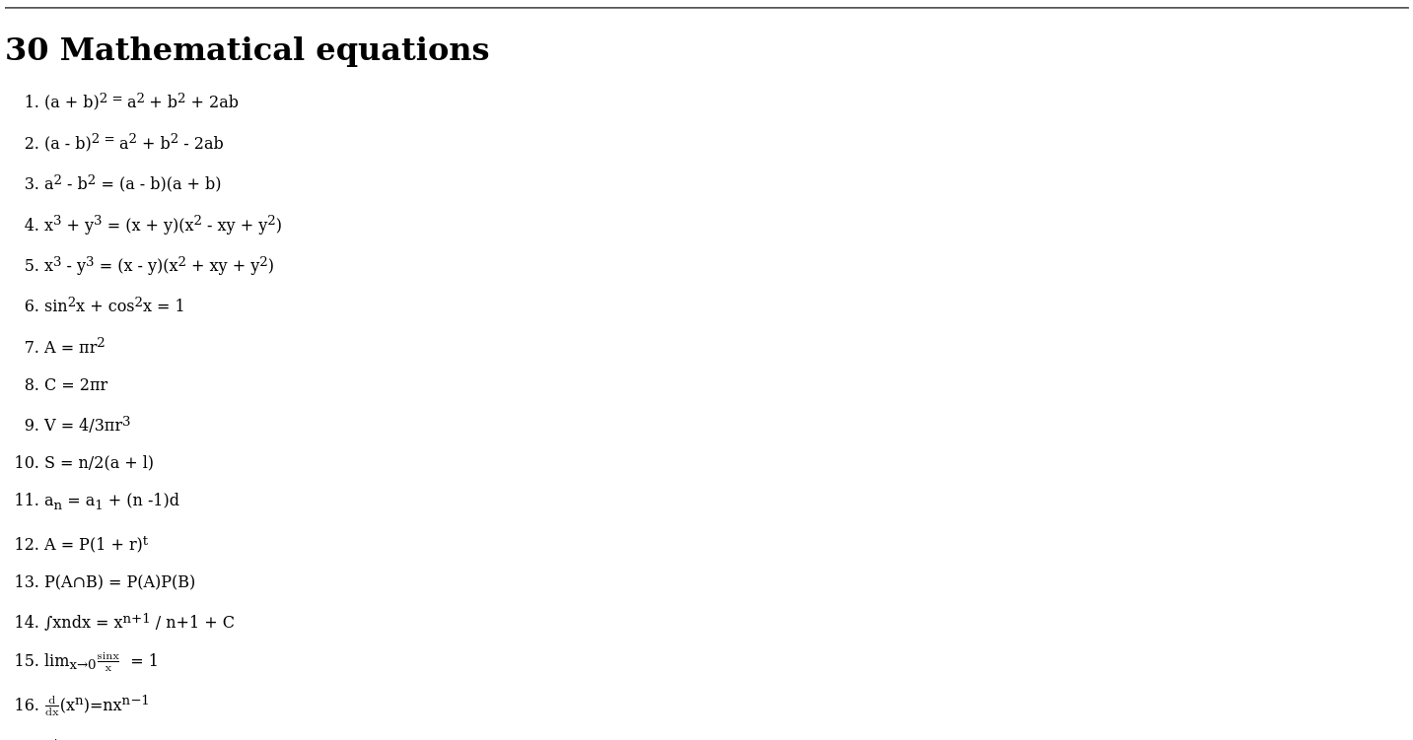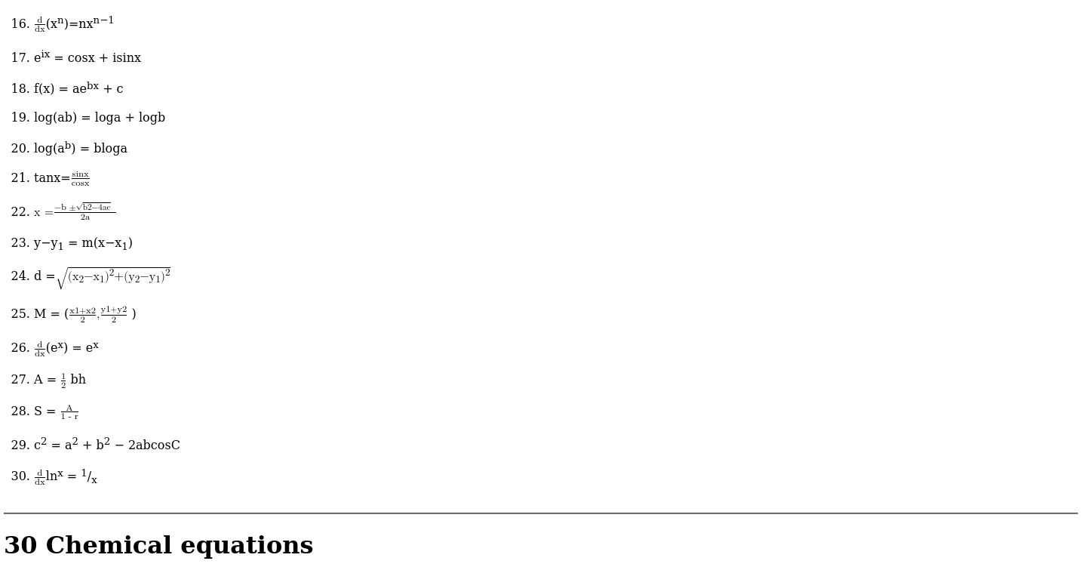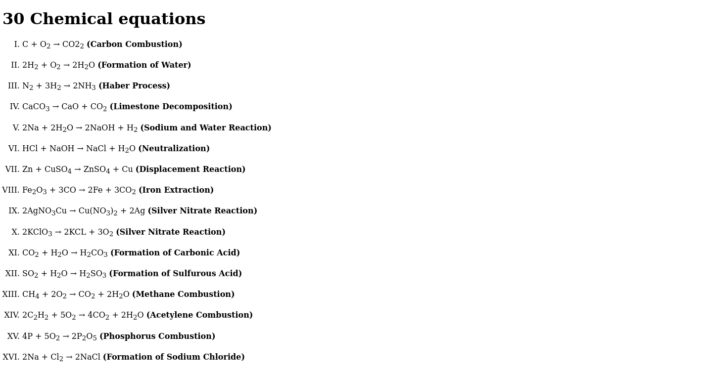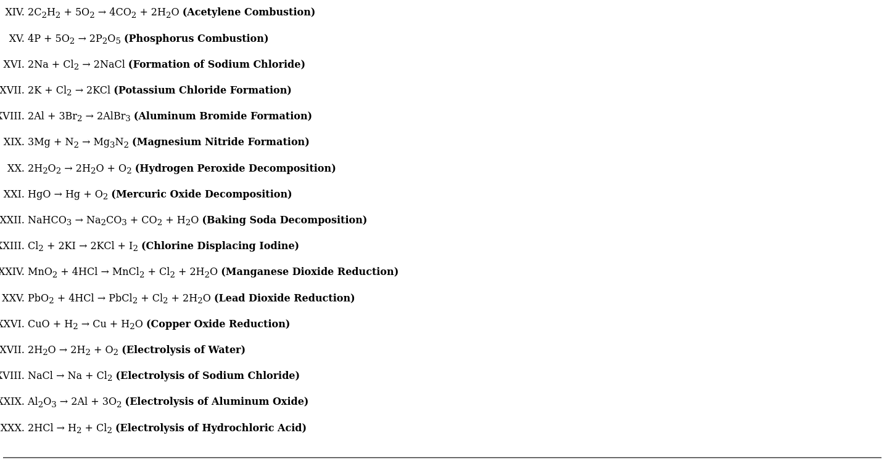

**SUBMITTED BY:**

ABHINASH TOIJAM

ROLL NO. : BC 1953

SEC : A

BCA 4TH SEM